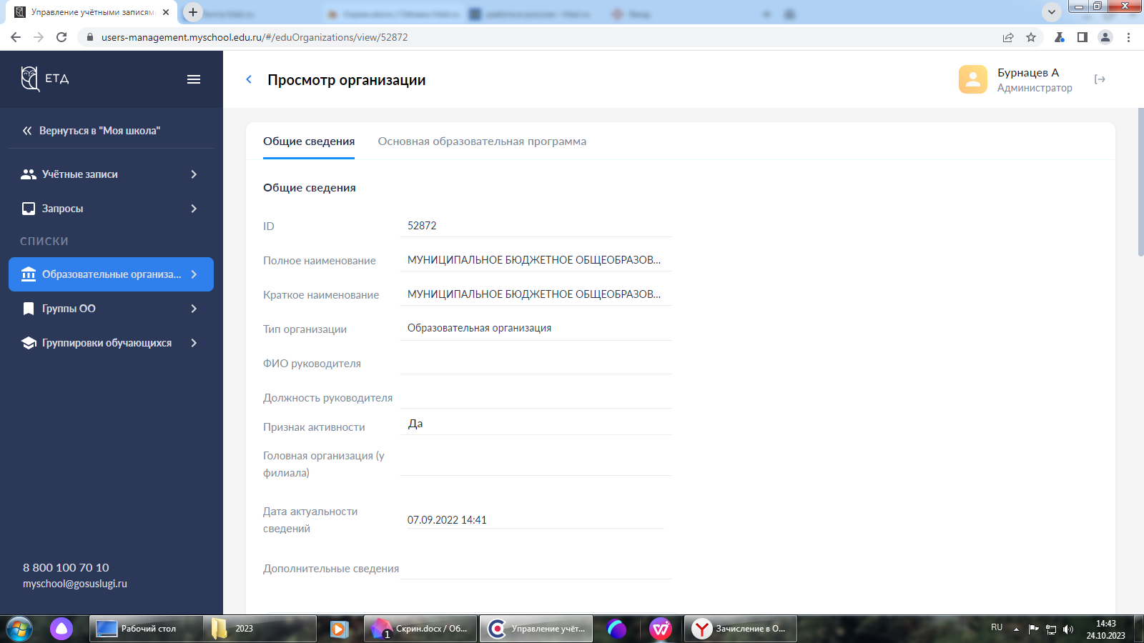
https://usersmanagement.myschool.edu.ru/#/eduOrganizations/view/52872

